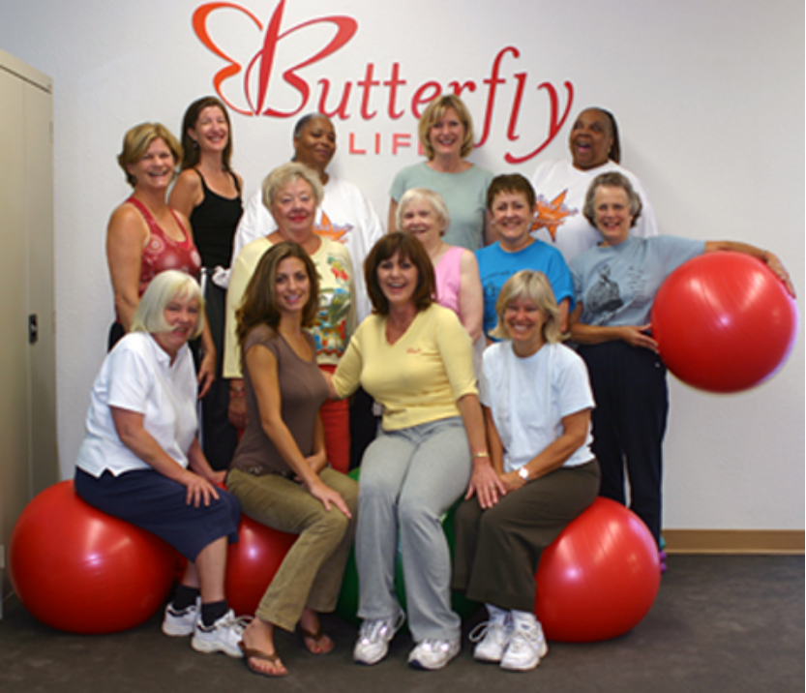
Butterfly Life is the new innovative 30-minute workout center designed for women located in the Midtown Shopping Center. Come in for circuit training or group exercise classes.

